Project Design Phase
Proposed Solution
Date | 09 September 2026
Student Name | Jetti Harika
Project Name | Automated Network Request Management in ServiceNow
Maximum Marks

Proposed Solution
The proposed solution is a ServiceNow-based Automated Network Request Management capability. A Network Request catalog item, backed by a custom network request table, captures request type, access level, business justification, and related network configuration items. UI Policies dynamically reveal fields based on selections (for example, an Existing ID field when the connection type is Existing, or a free-text field when the device type is Others). A custom relationship links approval records to the request table so approvals can be tracked against each request, and Flow Designer automates record creation, approval requests, email notifications, and status updates end to end.
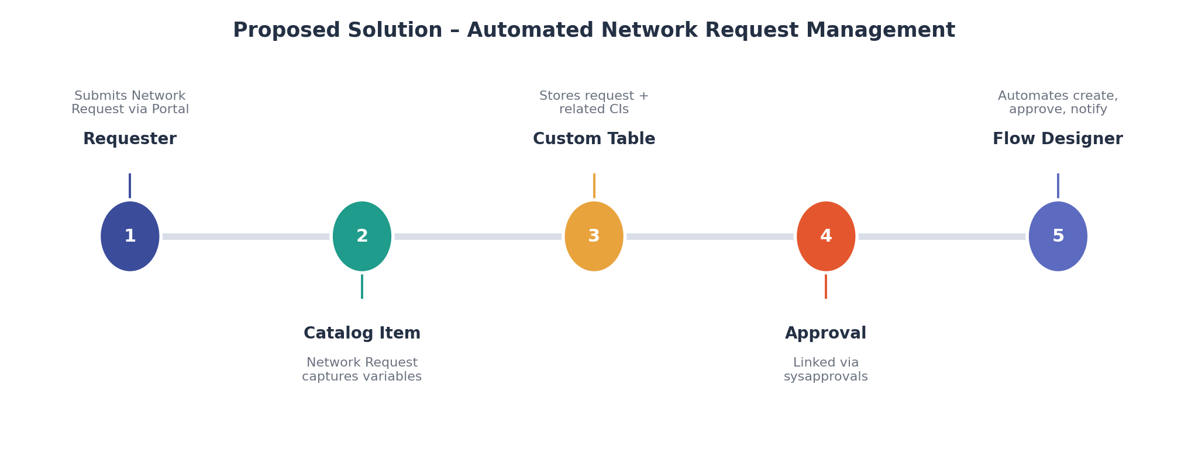
Figure 1: Proposed solution representation.
S.No. | Parameter | Description
1 | Problem Statement | Network teams need a consistent, automated way to receive, approve, and fulfil network-related service requests such as new connections, access changes, and device requests.
2 | Idea / Solution description | A catalog-driven Network Request form maps into a custom network request table; Flow Designer automates record creation, approval routing, notification, and status updates.
3 | Novelty / Uniqueness | Combines standard ServiceNow tables with a purpose-built network request table, a custom relationship linking approvals (sysapprovals) to the request record, dynamic UI Policies for device/connection type, and full Flow Designer automation.
4 | Social Impact / Customer Satisfaction | Reduces turnaround time and manual back-and-forth for network requests, giving requesters clear visibility and network teams a standardized queue.
5 | Business Model / Revenue Model | Internal IT/network operations tool; no direct revenue model is required.
6 | Scalability of the Solution | Can be extended with SLA-based escalation, CMDB-linked network configuration items, richer approval hierarchies, and reporting dashboards.

